
Modern Consumer
Collections Application

Operating Manual

Contents at a glance

Page #

- Collections Window instructions
- Collections Interface
- Printing Window instructions
- Printing Interface
- Sample Invoice Letter
- Sample Collections Letter
- Callbacks Window instructions
- Callbacks Interface
- Reports Window instructions
- Reports Interface
- Sample Report
- Profile Manager Window Instructions
- Profile Manager Interface

Last updated 1/11/05
By: Christopher Harty

Collections Window

Start:
When the collections window is first opened up there are four options that you are limited to in the “Customers” frame.
- You may search for a customer by typing the name of the company in the search field. Wait for the search to come to a stop, and if the search found the correct item, just press the “Enter” key and it will display details for that customer.
- Double click the customer row and view details for that customer.
- You may click on the “Callback” button that looks like a calendar. (see “callback Interface” for more information).
- You may click the “→” button that has an arrow pointing to the right (If this option is available). This will let you change the information you are able to view. (see “Collections Interface” for more information).

Note: These options are the only options available at first and will be available while your profile allows.

Once in a record:
While in a customer information additional options become available.

In the “Contact Info” frame, you may:
- Change the “importance level”.
- Change to “Upfront” or “Not Upfront”.
- Send a message via email to a customer from the “email a customer” button.
- View company contact information.
- View invoice details, balances (Bold Font), and payments (Red Font).

In the “Notes” frame, you may:
- View previously created notes.
- Create a message (you may also set a callback date and timestamp for your message).
- Send a Alert via email to Mike Fishman, Steve Leavy, and Ines Cedeno from the “Email Alert” button.
- Click on the “Print” button, when you wish to print out an Invoice or Collections Letter.

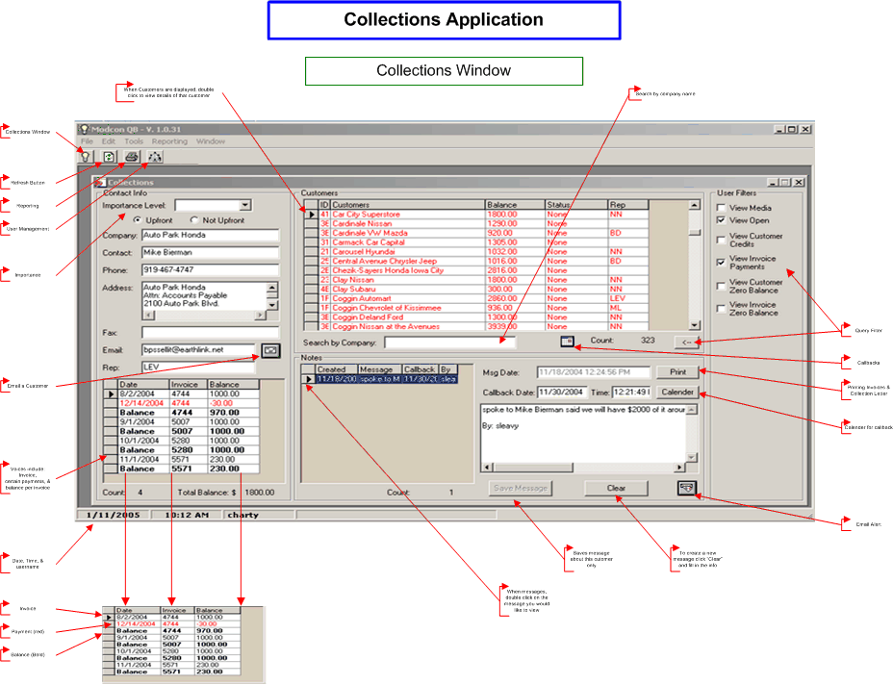

Printing Window

At any time in the “Printing Window” you may use the following options.

While in the “Customer” frame, you may temporarily change (for the purpose of making the Invoice and Collection letter accurate):
- The “Datestamp” for the Invoice or Collection letter.
- The “Due Date” for a Collections letter.
- Company information, if there is a typo or needed correction.
- Change the Invoice number you wish to view in an Invoice Letter.

Note: You must press the “Update” button, then the “Preview” button after you make a change for it to temporarily affect the letters you are creating. Any changes that are made are only made while the “Printing Window” is open.

While in the “Create a Letter” frame, you may:
- Preview an Invoice Letter
- Preview a Collections Letter
- Print the current previewed Invoice Letter
- Print the current previewed Collections Letter

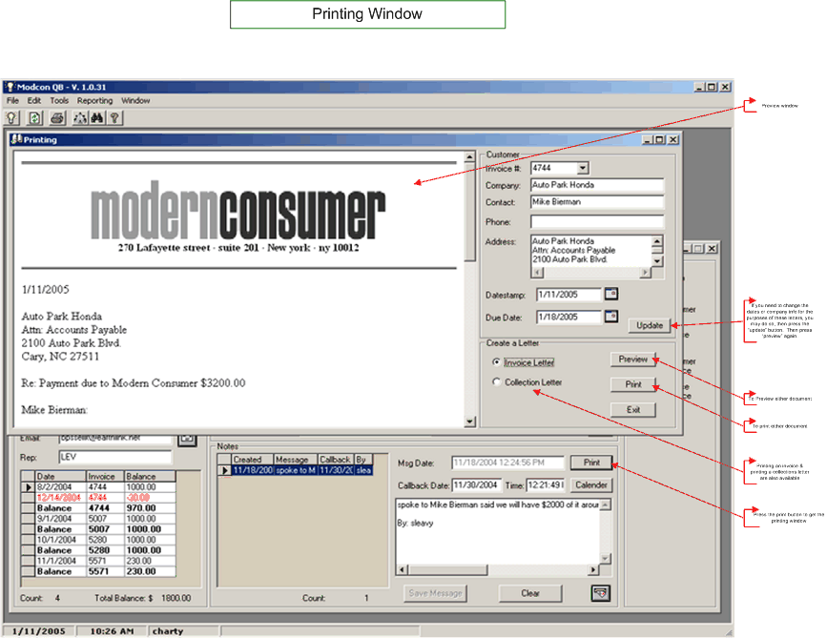

Callbacks Window

At any time in the “Callbacks Window” you may use the following options:

1. Click the button that looks like a calendar to search for callbacks from a different date.
2. When a callback record is displayed, you may double like the record to see the details of that record.

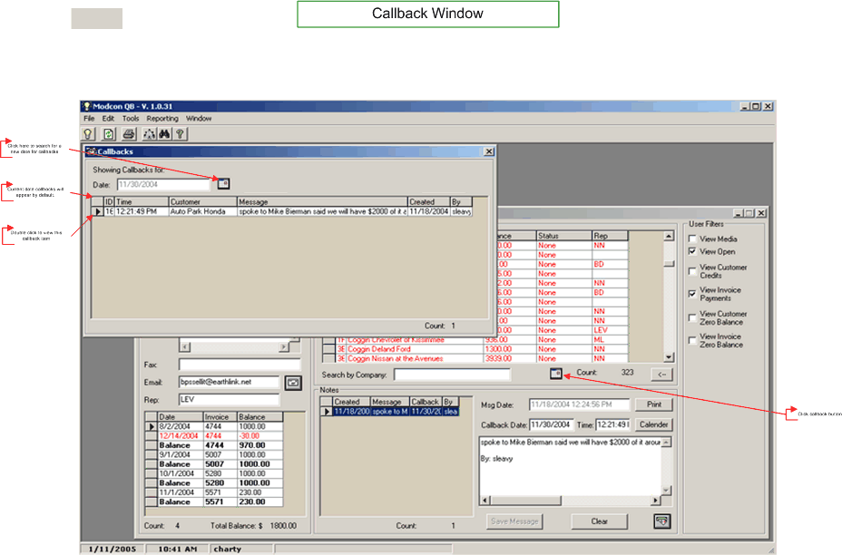

Reports Window

To create a report:
- Choose an option, either “All” or “By user”
- If “All” was chosen, then skip this step. If “By User” was chosen, then choose the User from the drop down.
- Click the “Generate Report” button and the report will start to build. You will see the “count” label at the bottom count up to the maximum record generated from the report. There may be a short delay thereafter to display a preview of the report, if it is big enough.
- Once the report is generated, you may press the “Print” button to print it to a printer.

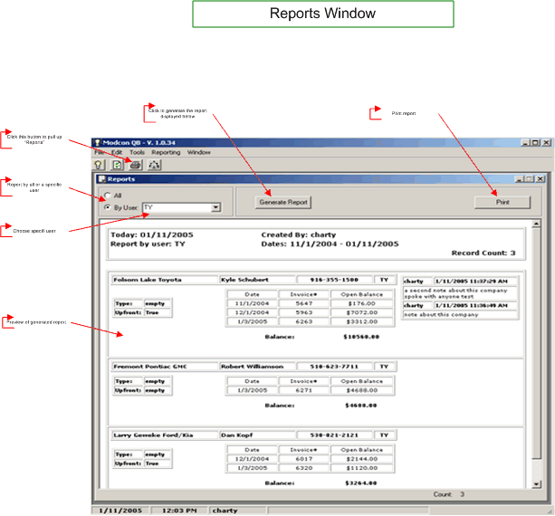

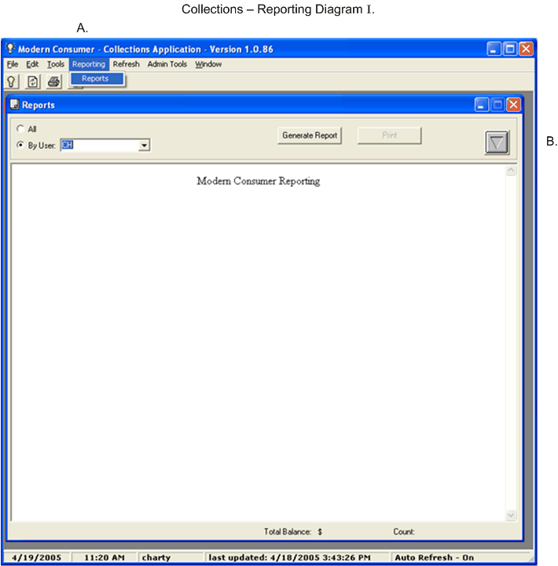

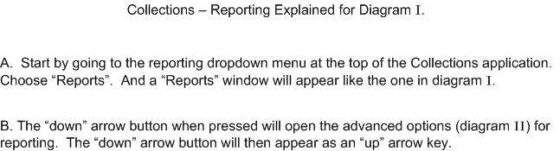

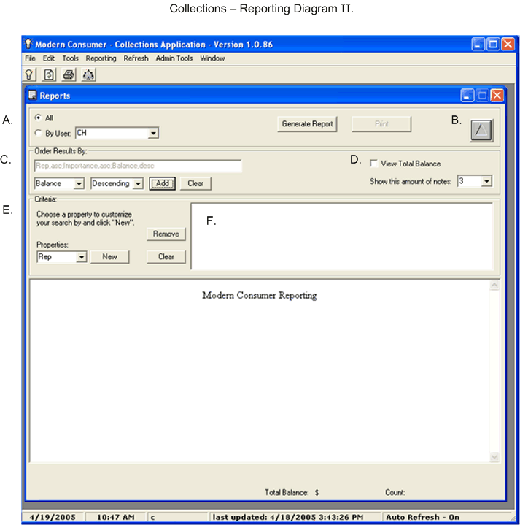

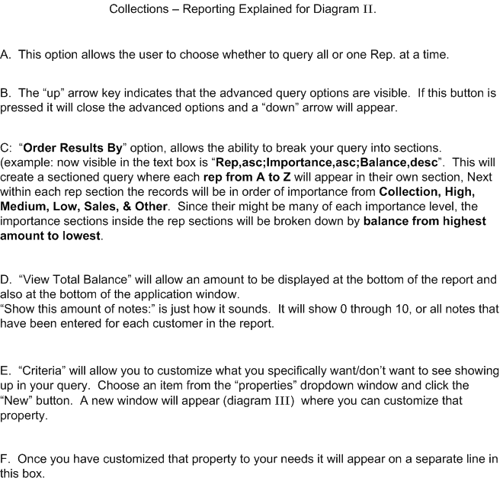

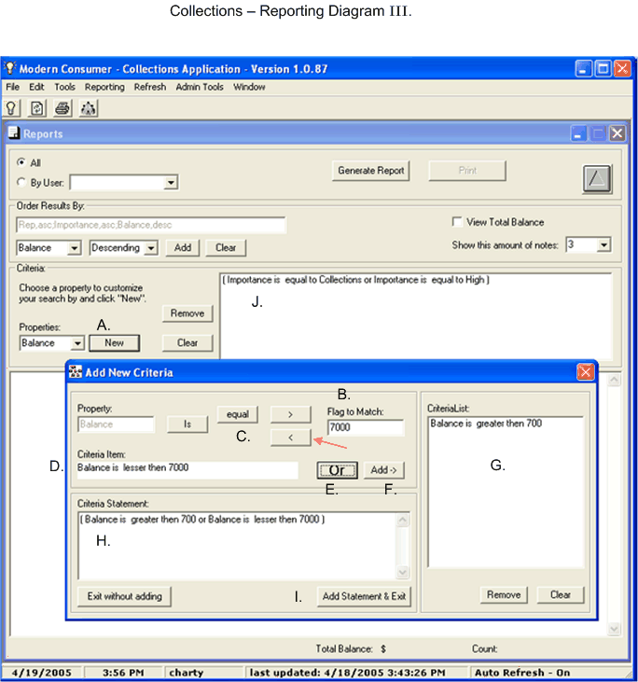

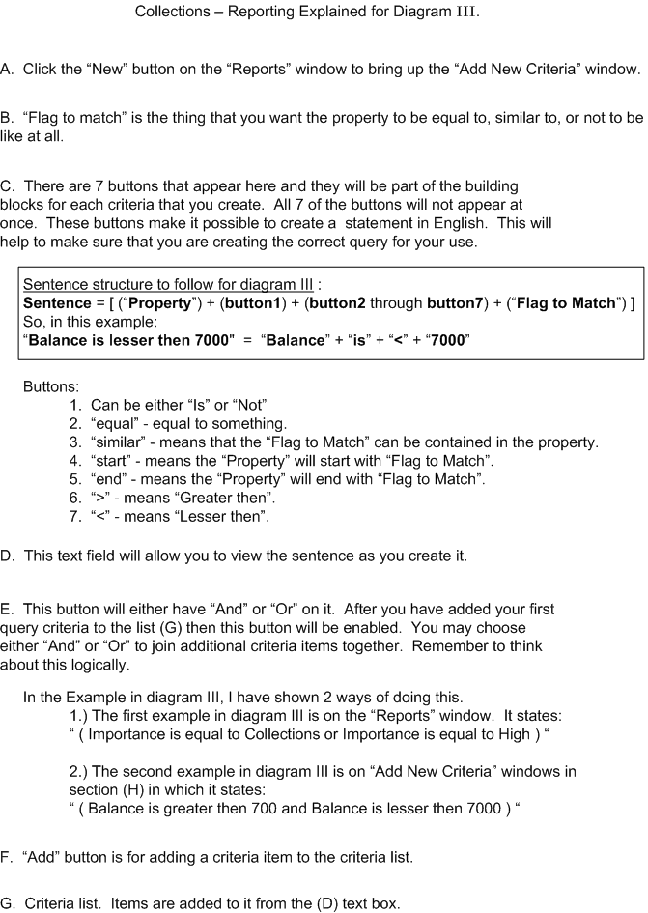
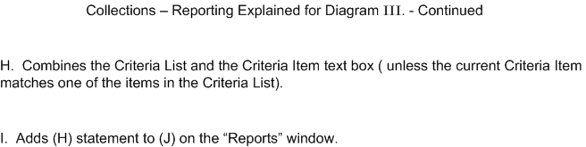

Profile Manager Window

To view/modify a user’s profile start in the “Profile” frame, so you may:
- Choose a user profile from the drop down.
- Once a profile is chosen, all the features for that user are displayed automatically.
- To modify a feature from the list, simply click once on the feature you wish to modify. This will show the feature on the right side “Edit Attribute” frame. Once this information is displayed, you may go to the bottom and edit the value where is says “1 = yes / 0 = no“. The while field will only accept a 1 (one) or a 0 (zero). Note: when you enter a 1 or 0 it will automatically update that profile.
- To modify a date restriction feature, simply change the values in the “Date Restrictions” frame and press the “Update” button also found in that frame.
- To Disable/Enable a user profile, simply choose a profile other than your own and check (Enabled) / uncheck (Disabled) the box in the “Profile” frame and press the “Update” button found in that same frame.

